Assignment
Fundamental Programming
(LAB: 1)
NAME: Majid Ali
CMS ID: 053-25-0017
PROGRAM: Software engineering (Section: A)

Question 1:
Write a program that displays the triangle pattern using a single output statement using escape sequence.
#include<iostream>
using namespace std;
int main(){
cout<<"*\n";
cout<<"* *\n";
cout<<"* * *\n";
cout<<"* * * *\n";
return 0;
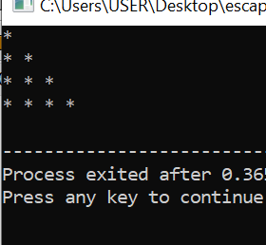
}

Question 2:
Write a program that displays the following output:
‘P’ ‘r’ ‘o’ ‘g’ ‘r’ ‘a’ ‘m’ ‘m’ ‘i’ ‘n’ ‘g’
“Fundamentals”.

#include<iostream>
using namespace std;
int main(){
cout<<" 'P'\t'r'\t'o'\t'g'\t'r'\t'a'\t'm'\t'm'\t'i'\t'n'\t'g'"<<endl;
cout<<" \"Fundamentals\".";
return 0;}

Question 3:
Write a program that displays the 5×2 matrix using a single output statement using escape sequences.
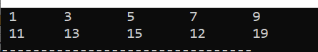

Question 4:
Write a program to print your first name with stars (*) using escape sequences.
For Example:
#include<iostream>
using namespace std;
int main(){
cout<<"********\n";
cout<<"*ZAINAB*\n";
cout<<"********";
return 0;
}
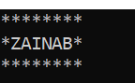

Question 5:
Write a program that displays the pattern of asterisks shown below using escape sequences.
#include<iostream>
using namespace std;
int main(){
cout<<"\n";
cout<<"\t *\n";
cout<<"\t * *\n";
cout<<"\t * *\n";
cout<<"\t * *\n";
cout<<"\t * *\n";
cout<<"\t * *\n";
cout<<"\t * *\n";
cout<<"\t * *\n";
cout<<"\t *\n";

return 0;
}
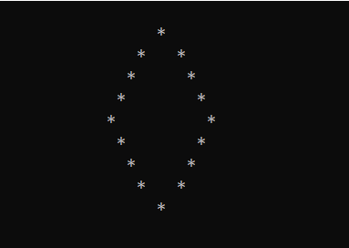

Question 6:
Write a program that displays the triangle pattern using a single output statement using escape sequences.
#include<iostream>
using namespace std;
int main(){
cout<<"\t *\n";
cout<<"\t * *\n";
cout<<"\t * *\n";
cout<<"\t * *\n";
cout<<"\t * *\n";
cout<<"\t *************\n";
return 0;
}
